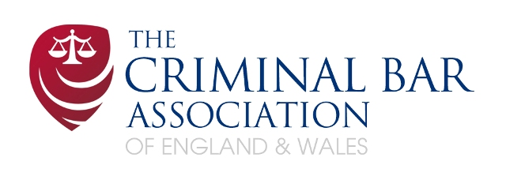

Dear Supporter,

I am writing to ask you to consider making a donation to the Criminal Bar Association Hardship Fund.

**What action is being undertaken by Criminal Barristers ?**

80% of the members of the Criminal Bar Association have voted to refuse to attend at court for legal aid defence cases for an indefinite period, commencing on the 5th September 2022, in addition to continuing to refuse to accept new instructions, unless and until Government propose an acceptable settlement for their fees, in order to save the Criminal Bar and preserve the criminal justice system in England and Wales.

This is an escalation of the present alternate weeks of action (when barristers refuse to attend at court) and refusal of new instructions, which has been ongoing since June.

**Why are Criminal Barristers taking action ?**

Successive governments have failed to properly remunerate those working in the criminal courts and as time has gone by the exodus from the profession has resulted in less than 2400 dedicated criminal barristers prosecuting and defending in our criminal courts. 300 barristers departed criminal practice last year alone with the median income for those in their first 3 years of practice at £12,200 per annum. This is wholly unsustainable.

The independent review conducted by Sir Christopher Bellamy reported on 30 November 2021 that an immediate minimum increase to legal aid fees of 15% annually, was necessary to stop barristers leaving and to encourage new entrants to the Criminal Bar. He said that there was “*no scope for further delay*”.

It was obviously urgent given the government’s own predictions at the time of the need for more criminal advocates, not least because of the backlog of cases already in the system, that increased further during the pandemic (and now exceeds 59,000).

The review made other important recommendations, following which members of the Criminal Bar Association voted to take action to achieve: a better remuneration settlement, the creation of an independent pay review body, and payment for previously unpaid written work which, together with a second brief fee for advance cross-examination cases (Section 28) are necessary if we are to retain and recruit in the short-term.

Despite the urgency of the situation, the government failed to act. Before the Criminal Bar Association began its action in April 2022, 1,000 criminal cases had to be postponed, and so were delayed, due to the lack of a prosecution or defence barrister.

Eventually the government agreed to increase fees by 15%, but only on new cases and only from October 2022. This of course does not address the urgency of the situation and the lack of increased remuneration for criminal barristers working on the almost 60,000 cases already in the system. Work on these cases will continue post October 2022 and up to trial dates fixed in the years ahead.

Initially, Criminal Bar Association members voted to withdraw their goodwill, refusing “returned briefs”, but as the Government refused to engage in negotiation, the action escalated to refusal of new instructions as well as days and then weeks of action, when criminal barristers withdrew from attending court.

This action is unprecedent and is last resort. Criminal barristers, in having to take this action, are personally adding to the financial hardship that so many of them were already suffering. Each one of them is self employed, and every day out of court, not taking a new case, creates a very real and pressing financial impact, particularly for the most junior who are struggling to absorb the additional financial pressure and for mid-level barristers who have increased childcare and caring commitments.

**How can I make a donation to the Criminal Bar Association Hardship Fund?**

The Criminal Bar Association is requesting those who support criminal barristers and an independent Criminal Bar to make donations to the CBA Hardship Fund, kindly administered by the Bar Council, for distribution to those most in need.

The Criminal Bar Association has set up a panel of Silks, who will assess applications from its members for hardship grants.

**We are extremely grateful to you for any financial support you can give to members of the Criminal Bar Association at this crucial time in our history, as we stand together, united, in defence of the criminal justice system.**

**The details of how you can make a donation to the Criminal Bar Hardship Fund are set out overleaf. Please use the payment reference SUPPORT2022 and email confirmation of the date and amount of your donation to** [**Hardshipfund@criminalbar.com**](mailto:Hardshipfund@criminalbar.com)

Having taken advice and to avoid potentially creating a trust or charitable trust in respect of donations, all donations to the Hardship Fund are gifts to the CBA to use as it sees fit in its absolute discretion. The CBA intends, however, to use all donations for its Hardship Fund. In the unlikely event there is surplus, the CBA intends to use these monies to fund its educational activities.

Yours Sincerely,

