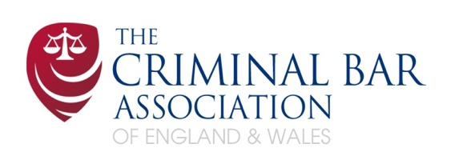

Criminal Bar Association Chair’s Essay Award.

This application form is to be used in order to apply for one of the three awards from The Criminal Bar Association

The CBA encourage applications from those in practice under 7 years’ call and undertaking publicly funded work in whole or in substantial part.

Applicants must:
- be a member of the association’.
- be either a pupil or currently practise as a Barrister and hold a current practising certificate and be under 7 years’ call.

Please complete THIS application form and return, along with your essay on your chosen AWARD, to the CBA Administrator by noon on Friday 28TH July 2023

applicants will be notified of the outcome of their application shortly after 1st AUGUST.

PERSONAL Information provided will be utilised for contact over this Award.

Please indicate which award you wish to apply for and answer the question for that award (between 1000- 1200 words).

RASSO AWARD
"Cross-examination of complainants in rape trials has become so stringent that a defendant cannot have a fair trial.”

INTERNATIONAL AWARD
“In his foreword to Shaheen Fatima KC’s book Using International Law in Domestic Courts (Hart, 2005), Lord Bingham wrote “national courts … are called upon to consider and resolve issues turning on the correct understanding and application of international law, not on an occasional basis, now and then, but routinely, and often in cases of great importance.” To what extent is that true of the current domestic criminal law of England and Wales?”

EQUALITY & DIVERSITY AWARD
“To what extent have the recommendations in the Lammy Report been applied to the sentencing process and has this had an effect in mitigating any bias and/or disparities in outcomes based on ethnicity?”

Section 1 - Personal details

Name

E-mail address

Chambers & address
Mobile telephone number

Section 2 - Professional details

Inn of Court

Date of Call
Are you a member of any of the circuits?
If so, please specify.

Is it your present intention to continue practising at the criminal Bar for the foreseeable future? (this will not affect the judging of the essay)

Signed:

Name:

Date:

