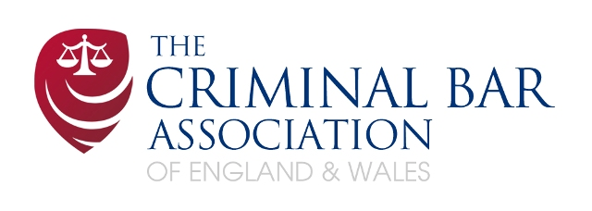

CBA ELECTED MEMBERS ELECTION
You may cast your vote marked with a simple "X"
You have 5 Votes

Name, Chambers,  Silk  (up to two places) | X | Name, Chambers,  Over 7 Years’ Call | X | Name, Chambers,  Under 7 Years’ Call  (at least one place) | X
Adam Davies QC, 3 Temple Gardens |  | Martin McCarthy, Farringdon Chambers |  | Emma Stuart-Smith, 25 Bedford Row
Sally Ann Hales QC, 18 Red Lion Court |  |  |  | Katrina Jamieson, 2 Bedford Row
David Hislop QC, Doughty Street Chambers
Orlando Pownall QC, 2 Hare Court
Bernard Richmond QC, Lamb Buildings

Please return your completed ballot paper to:-

Aaron Dolan, CBA Administrator, 289 – 293 High Holborn, London, WC1V 7HZ, DX: 240 LDE

by 4.00 p.m. on Friday 16 November 2012

Name (Please print)________________________________

Signed____________________________________
I am a member of the Criminal Bar Association.

Chambers_________________________________

Date______________________________________

