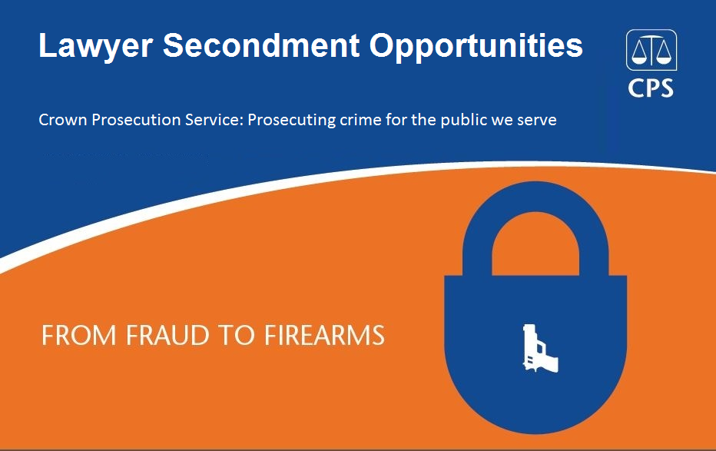

Location: Central London

The Crown Prosecution Service (CPS) is seeking to recruit suitably qualified lawyers (barristers or solicitors) to join CPS on a fixed-term appointment as a Crown Prosecutor for periods between 60 days (3 months) and 120 days (6 months).

The CPS is the principal prosecuting authority for England and Wales, acting independently in criminal cases investigated by the police and others.

Successful candidates will be offered the opportunity to take part in a range of criminal casework work appropriate to their level of experience. The casework will be primarily office based case preparation but will also include some advocacy. Successful candidates will ideally be members of the CPS Advocate Panel as follows:

- Level 1 CPS Advocate Panel members aspiring to level 2, to provide magistrates’ courts and Crown Court case preparation and advocacy

- Level 2 CPS Advocate Panel members aspiring to level 3, to provide Crown Court case preparation and advocacy

- Level 2 CPS Advocate Panel members aspiring to level 3 and future RASSO advocates, to provide Crown Court case preparation in RASSO Units and advocacy

- Level 3 Rape List Panel members to provide Crown Court case preparation in RASSO Units, including the option of advocacy.

Subject to agreement, the positions are likely to be suitable to those wishing to take advantage of flexible working patterns such as part-time working, compressed hours or job share. .

Successful candidates will be designated as Crown Prosecutors for each day worked during the period of the appointment and will take casework decisions appropriate to their level. It should be noted that the agreed number of days to be worked and working patterns will be subject to agreement.

Fixed term appointments provide an excellent opportunity for lawyers to develop their skills and ability, relationship with CPS and career as a prosecuting advocate.

The opportunity brings a number of benefits, including:

- Unparalleled prosecutorial experience which will add to a portfolio of skills and will be likely to assist those seeking to progress to a higher level on the CPS Advocate Panel.

- Remuneration at a daily rate basis, based on the actual number of days worked

- Flexibility within the period of appointment to agree ‘release days’ to allow existing commitments to be met

- Development of an in-depth understanding of CPS practice and procedures and the role of the Crown Prosecutor

- Access to CPS training and support

- CPS employee benefits such as annual leave on a pro rata basis

Candidates must be fully qualified barristers or solicitors in possession of a practising certificate and, ideally, members of the CPS Advocate Panel. They will also be compliant with professional regulators’ requirements and competence standards. Recent previous experience of prosecution work is highly desirable. Training will be provided to ensure that successful candidates fully understand the role and the requirements of them during the period of the appointment.

Opportunities will commence as soon as practicable in 2016 (other opportunities will also be available later in the year) with the minimum period for placement being a commitment to 60 days (3 months) and the maximum being 120 days (6 months). Advocates who complete an initial appointment will be permitted to either extend or re-apply, subject to agreement.

Individuals who would like to apply should send a full CV and covering letter to the CPS London Recruitment Team at HRAdvice.London@cps.gsi.gov.uk by 11 August 2016.

The covering letter should include details of the period of secondment being sought, any requirement for flexible working conditions and any other matters you wish to bring to our attention.

The CPS is an equal opportunities employer and applications are sought from all interested candidates.

If prospective applicants or Chambers representatives have any questions or would like to meet to discuss the benefit or terms of these opportunities, please contact Keith Milburn on 020 3357 0803.

